**Program/ Output Instructions:**

For output we run gcc Assign2.c –pthread

The program successfully compiles and runs without any errors or compilation issues.

**Program explanation:**

**Circular Buffer Queue**: I have used a circular buffer with BUFFER_SIZE of 32 defined in program. The buffer had two functions one to enqueue data into the buffer and other to dequeue data in FIFO Order.

**Threads:** We also have two declarations first is PROD_THREADS which are Number of Producers Threads 0,2 goes by even numbers and CONS_THREADS which are Number of Consumer Threads goes by 1 as odd i.e in this program we have 2 producers and 1 consumer where Thread 0 and 2 are producers and Thread 1 is consumer (3 threads). The producer is implemented by void *producer (void *param) and consumer by void *consumer (void *param).

The producer thread inserts data which is a random number from 0 to 10 in the buffer if the buffer is full it displays a message and waits will the buffer is empty to insert data again. Same with consumer thread we will remove data from buffer in the FIFO order and if the buffer it empty it cannot further remove the data from the buffer and display a message that buffer is empty. We have used use two semaphores where one indicates a full queue and the other indicates an empty queue. The program executes successfully.

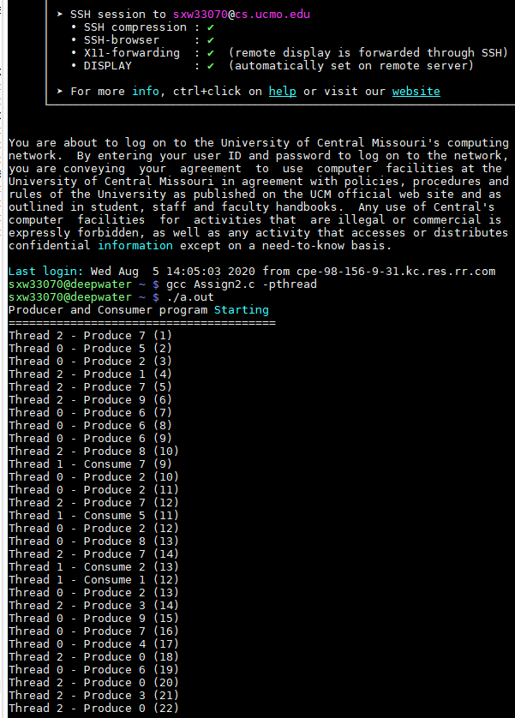

The program display an BUFFER IS FULL message when the buffer becomes full

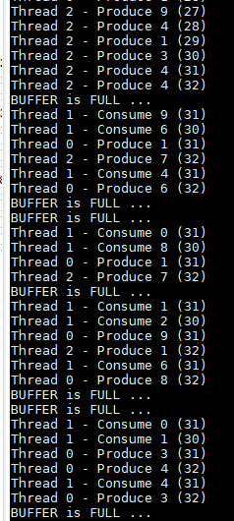

Similarly program display an BUFFER IS EMPTY message

